**MODULE: 1**

**SE=> OVERVIEW OF IT INDUSTRY**

**Q1 What is software? What is software engineering?**

**ANS);= n a computer system, the software is basically a set of instructions or commands that tell a computer what to do. In other words, the software is a computer program that provides a set of instructions to execute a user’s commands and tell the computer what to do. For example like ms-word, ms-excel, powerpoint, etc**

**Software Engineering is the process of designing, developing, testing, and maintaining software. It is a systematic and disciplined approach to software development that aims to create high-quality, reliable, and maintainable software**

**.**

**CUSTOMISED SOFTWARE EG;-RAILWA**

**GENERAL PURPOSE E;G-MS-WORLD, PHOTOSHOPE ETC;.**

**LANGUAGE PROCESSOR AND DEVICE DRIVE E;G-INTERPRETER,COMPILER ETC..**

**OPERATING SYSTEM E:G:- LINUX WINDOWS ETC.**

**APPLICATION SOFTWARE**

**SYSTEM SOFTWARE**

**TYPE OF SOFTWARE**

**Q2. Explain types of software**

**ANS:-**

**1) Operating System**

**2)Language Processor**

**3)Device Driver**

**1)Application Software**

**General Purpose Software**

**Customize Software**

**Utility Software**

**2)System Software**

**system software is software that directly operates the computer hardware and provides the basic functionality to the users as well as to the other software to operate smoothly**

* **Operating System: It is the main program of a computer system. When the computer system on it is the first software that loads into the computer’s memory. Basically, it manages all the resources such as computer memory, CPU, printer, hard disk, etc.,**
* **Language Processor: As we know that system software converts the human-readable language into a machine language and vice versa. So, the conversion is done by the language processor. It converts programs written in high-level programming languages like java, c, c++, python, etc**
* **Device Driver: A device driver is a program or software that controls a device and helps that device to perform its functions. Every device like a printer, mouse, modem, etc.**

## ****1)Application Software****

**Software that performs special functions or provides functions that are much more than the basic operation of the computer is known as application software.**

1. **General Purpose Software: This type of application software is used for a variety of tasks and it is not limited to performing a specific task only. For example, MS-Word, MS-Excel, PowerPoint, etc.**
2. **Utility Software: This type of application software is used to support the computer infrastructure.**

**Q3) What is SDLC? Explain each phase of SDLC;**

**ans;-**

**the software development life cycle sdlc is a process used by software development organizations to plan, design, develop, test, deploy, and maintain software applications.**

**sdlc software development life cycle is used in every software development company because it is the root of the development cycle, if that model would not exist in the world, firstly no software can build secondly if any how it would be made, it’s not going to succeed it has no use, because of no maintenance**

**1.**[**requirements gathering and analysis:**](https://www.geeksforgeeks.org/requirements-gathering-introduction-processes-benefits-and-tools/)**this phase involves gathering information about the software requirements from stakeholders, such as customers, end-users, and business analysts.**

**2. design: in this phase, the software design is created, which includes the overall architecture of the software, data structures, and interfaces. it has two steps:**

* **high-level design hld: it gives the architecture of software products.**
* **low-level design lld: it describes how each and every feature in the product should work and every component.**

**3. implementation or coding: the design is then implemented in code, usually in several iterations, and this phase is also called as development.**

**things you need to know about this phase:**

* **THIS is the longest phase in sdlc model.**
* **THIS phase consists of front end + middleware + back-end.**
* **IN front-end: development of coding is done even seo settings are done.**
* **IN middleware: they connect both the front end and back end.**
* **IN the back-end: a database is created.**

**4. Testing: the software is thoroughly tested to ensure that it meets the requirements and works correctly.**

**5. Deployment: after successful testing, the software is deployed to a production environment and made available to end-users.**

**6. Maintenance: this phase includes ongoing support, bug fixes, and updates to the software.**

**there are different methodologies that organizations can use to implement the sdlc, such as waterfall, agile, scrum, v-model and devops.**

**Q4); What is DFD? Create a DFD diagram on FlipKart;**

**ANS);-level=0)DATA FLOW DIGRAM FOR FLIPKART 0LEVEL**

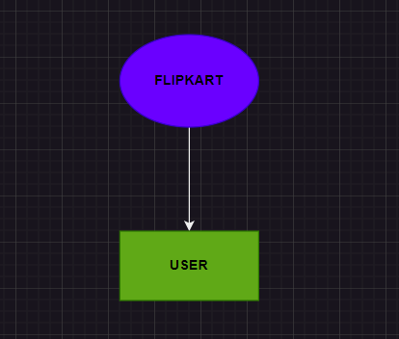

**level=1)DATA FLOW DIGRAM FOR FLIPKART 1L**

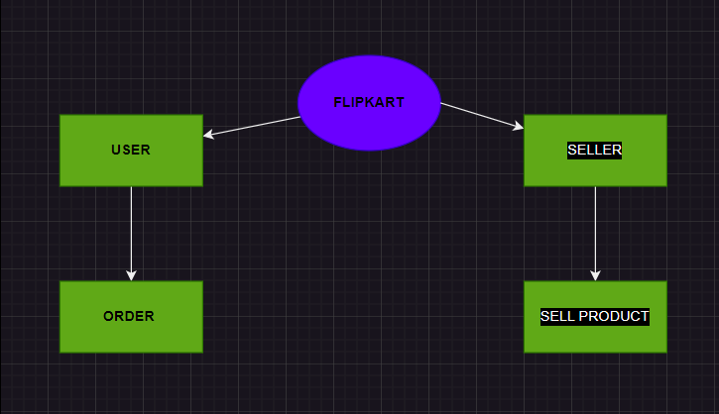

**level=2)DATA FLOW DIGRAM FOR FLIPKART**

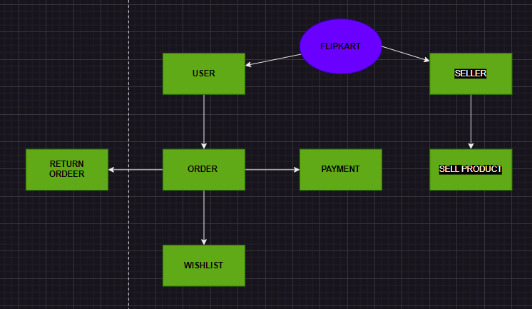

* **DFD is the abbreviation for data flow diagram. the flow of data of a system or a process is represented by dfd. it also gives insight into the inputs and outputs of each entity and the process itself.**

**5)WHAT IS FLOW CHART? CREATE A FLOWCHART TO MAKE ADDITION OF TWO NUMBERS**

**ANS)=> DATA FLOWCHART**

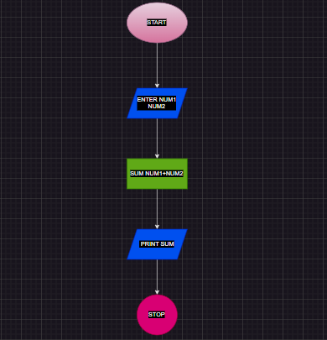

**A FLOWCHART is a type of diagram that represents a workflow or process. a flowchart can also be defined as a diagrammatic representation of an algorithm, a step-by-step approach to solving a task**

**BASIC =SYSMBOLS**

* **= START**
* **= PROCECER**
* **= FLOW**

**= DISICION**

**= DATA (INPUT)**

**6). What is Use case Diagram? Create a use-case on bill payment on paytm.**

**ANS);USE CASE DIGRAM**

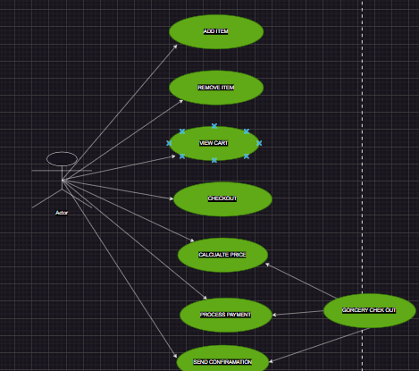

* **A Use Case Diagram is a type of Unified Modeling Language (UML) diagram that represents the interaction between actors (users or external systems) and a system under consideration It provides a high-level view of the system’s functionality**